1

Code:

libname college 'C:\Users\Samil\Desktop\Sem 1\Stats for programming\SAS 9.4';

*The dataset soccer is called from the lib name college;

**proc** **format**;

**data** _null_;

set college.soccer;

file 'C:\Users\Samil\Desktop\Sem 1\Stats for programming\SAS 9.4\SOCCDATA.TXT ';

put firstname lastname 'wears Number ' number '.';

**run**;

Log file:

47 data _null_;

48 set college.soccer;

49 file 'C:\Users\Samil\Desktop\Sem 1\Stats for programming\SAS 9.4\SOCCDATA.TXT ';

50 put firstname lastname 'wears Number ' number '.';

51 run;

NOTE: The file 'C:\Users\Samil\Desktop\Sem 1\Stats for programming\SAS 9.4\SOCCDATA.TXT ' is:

Filename=C:\Users\Samil\Desktop\Sem 1\Stats for programming\SAS 9.4\SOCCDATA.TXT,

RECFM=V,LRECL=32767,File Size (bytes)=0,

Last Modified=25 September 2017 10:22:13,

Create Time=19 September 2017 14:57:06

NOTE: 8 records were written to the file 'C:\Users\Samil\Desktop\Sem 1\Stats for programming\SAS

9.4\SOCCDATA.TXT '.

The minimum record length was 27.

The maximum record length was 35.

NOTE: There were 8 observations read from the data set COLLEGE.SOCCER.

NOTE: DATA statement used (Total process time):

real time 0.21 seconds

cpu time 0.03 seconds

Output:

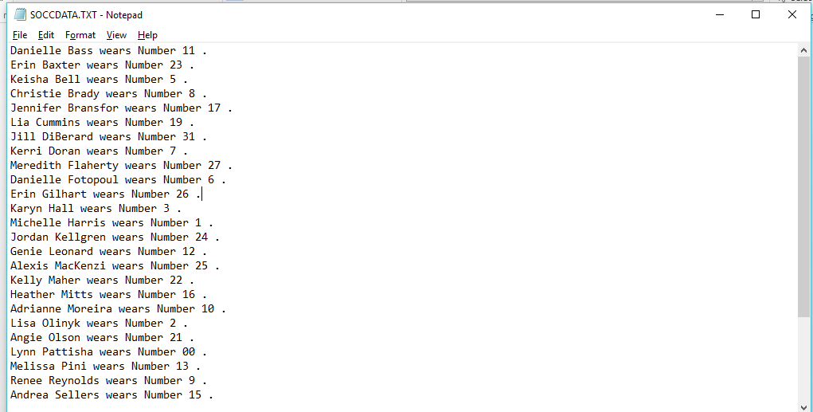

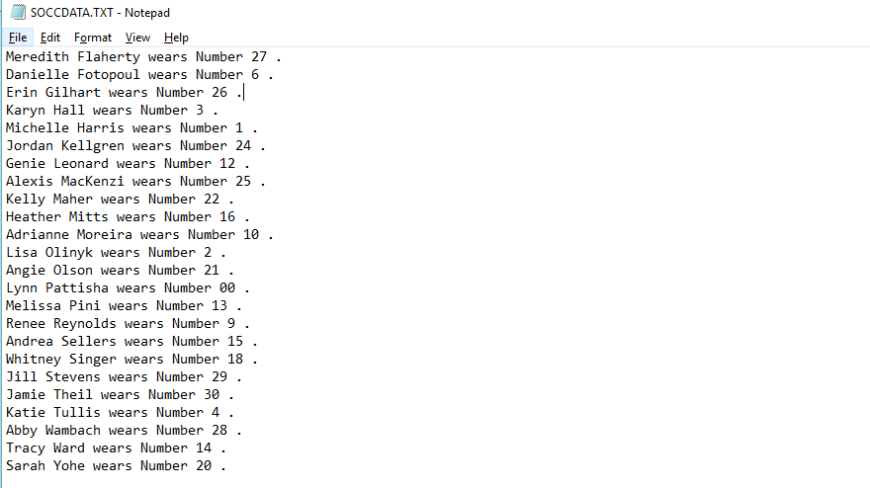

2

Code:

libname college 'C:\Users\Samil\Desktop\Sem 1\Stats for programming\SAS 9.4';

*The dataset hockey is called from the lib name college;

**proc** **format**;

**data** _null_;

set college.hockey;

file 'C:\Users\Samil\Desktop\Sem 1\Stats for programming\SAS 9.4\HCKYDATA.TXT ';

*where is used to filter;

where State = "Ohio";

put Date mmddyy10. ': ' State 'State ' OSU ', ' Team OPP;

**run**;

Log File:

53 data _null_;

54 set college.hockey;

55 file 'C:\Users\Samil\Desktop\Sem 1\Stats for programming\SAS 9.4\HCKYDATA.TXT ';

56 where State = "Ohio";

57 put Date mmddyy10. ': ' State 'State ' OSU ', ' Team OPP;

58 run;

NOTE: The file 'C:\Users\Samil\Desktop\Sem 1\Stats for programming\SAS 9.4\HCKYDATA.TXT ' is:

Filename=C:\Users\Samil\Desktop\Sem 1\Stats for programming\SAS 9.4\HCKYDATA.TXT,

RECFM=V,LRECL=32767,File Size (bytes)=0,

Last Modified=25 September 2017 10:29:37,

Create Time=19 September 2017 15:16:58

NOTE: 8 records were written to the file 'C:\Users\Samil\Desktop\Sem 1\Stats for programming\SAS

9.4\HCKYDATA.TXT '.

The minimum record length was 37.

The maximum record length was 45.

NOTE: There were 8 observations read from the data set COLLEGE.HOCKEY.

WHERE State='Ohio';

NOTE: DATA statement used (Total process time):

real time 0.11 seconds

cpu time 0.01 seconds

Output:

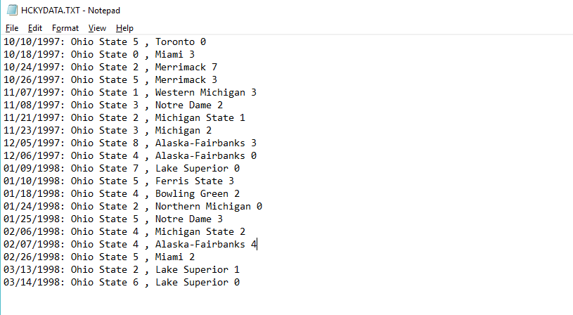

3

Code:

**data** college.manatees;

infile 'C:\Users\Samil\Desktop\Sem 1\Stats for programming\SAS 9.4\manatees.txt'firstobs=**2** expandtabs;

input YEAR WATERC LOCK RELAT PERIN NATUR UNDET;

*Column names have been changed;

label YEAR="In which year"

WATERC= "Water"

LOCK= "Lock"

RELAT= "Related"

PERIN="Perin"

NATUR="Natural"

UNDET="Undet";

**run**;

Title 'Manatees';

Footnote 'Confidential';

**proc** **print** data=college.manatees label /*Label syntax have to specified for the output to show the changed column names*/;

**run**;

/*Used to clear previously used title and footnote*/

Title;

Footnote;

Log File:

96 Title 'Manatees';

97 Footnote 'Confidential';

98

99 proc print data=college.manatees label /*Label syntax have to specified for the output to

99 ! show the changed column names*/;

100 run;

NOTE: There were 23 observations read from the data set COLLEGE.MANATEES.

NOTE: PROCEDURE PRINT used (Total process time):

real time 0.15 seconds

cpu time 0.03 seconds

101

102 /*Used to clear previously used title and footnote*/

103 Title;

104 Footnote;

Output:

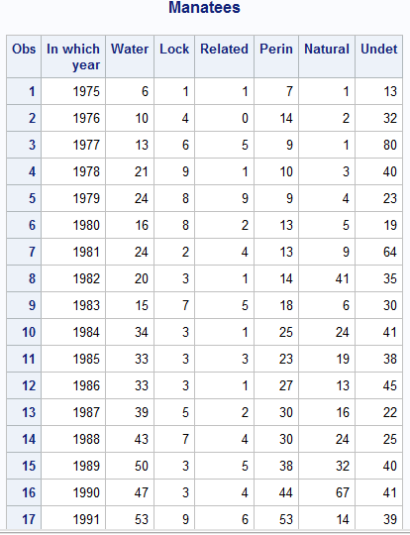

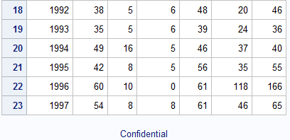

4

Code:

/*Formats*/

**proc** **format**;

value mileage low-**49999** = '<50,000'

**50000**-High = '>=50,000'

Other = 'Unknown';

value cost **0**-**4999** ='Economy'

**5000**-**10000** ='Moderate'

**10001**-high ='Expensive';

**run**;

/*Data set*/

**data** college.usedcars;

infile 'C:\Users\Samil\Desktop\Sem 1\Stats for programming\SAS 9.4\usedcars.txt' firstobs=**2** obs=**51** expandtabs ;

input Year **1**-**3** Manufacturer $ **9**-**22** Model $ **24**-**36** @**38** Miles comma6.0 @**49** Price dollar7.0 Dealer $**61**-**84**;

label Miles='Mileage'

Price='Cost';

Format Miles mileage.

Price cost.;

**run**;

Title 'UsedCars';

**proc** **print** data=college.usedcars label;

var Year Manufacturer Model Miles Price;

**run**;

Title;

Log file:

255 /*Formats*/

256 proc format;

257 value mileage low-49999 = '<50,000'

258 50000-High = '>=50,000'

259 Other = 'Unknown';

NOTE: Format MILEAGE is already on the library WORK.FORMATS.

NOTE: Format MILEAGE has been output.

260 value cost 0-4999 ='Economy'

261 5000-10000 ='Moderate'

262 10001-high ='Expensive';

NOTE: Format COST is already on the library WORK.FORMATS.

NOTE: Format COST has been output.

263 run;

NOTE: PROCEDURE FORMAT used (Total process time):

real time 0.04 seconds

cpu time 0.00 seconds

264

265 /*Data set*/

266 data college.usedcars;

267 infile 'C:\Users\Samil\Desktop\Sem 1\Stats for programming\SAS 9.4\usedcars.txt' firstobs=2

267! obs=51 expandtabs ;

268 input Year 1-3 Manufacturer $ 9-22 Model $ 24-36 @38 Miles comma6.0 @49 Price dollar7.0

268! Dealer $61-84;

269 label Miles='Mileage'

270 Price='Cost';

271 Format Miles mileage.

272 Price cost.;

273 run;

NOTE: The infile 'C:\Users\Samil\Desktop\Sem 1\Stats for programming\SAS 9.4\usedcars.txt' is:

Filename=C:\Users\Samil\Desktop\Sem 1\Stats for programming\SAS 9.4\usedcars.txt,

RECFM=V,LRECL=32767,File Size (bytes)=4743,

Last Modified=19 September 2017 22:29:21,

Create Time=19 September 2017 22:29:21

NOTE: 50 records were read from the infile 'C:\Users\Samil\Desktop\Sem 1\Stats for

programming\SAS 9.4\usedcars.txt'.

The minimum record length was 91.

The maximum record length was 91.

NOTE: The data set COLLEGE.USEDCARS has 50 observations and 6 variables.

NOTE: DATA statement used (Total process time):

real time 0.06 seconds

cpu time 0.06 seconds

274

275

276 Title 'UsedCars';

277

278 proc print data=college.usedcars label;

279 var Year Manufacturer Model Miles Price;

280 run;

NOTE: There were 50 observations read from the data set COLLEGE.USEDCARS.

NOTE: PROCEDURE PRINT used (Total process time):

real time 0.16 seconds

cpu time 0.06 seconds

281

282 Title;

Output:

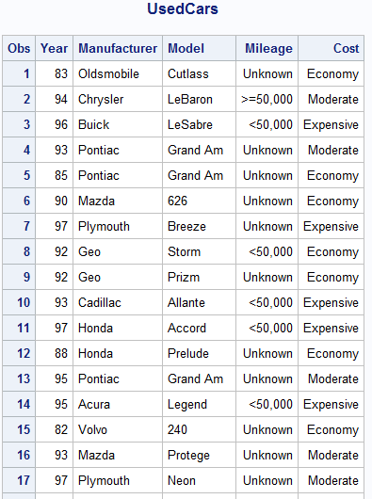

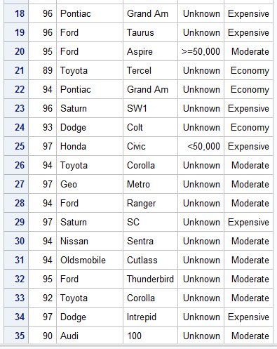

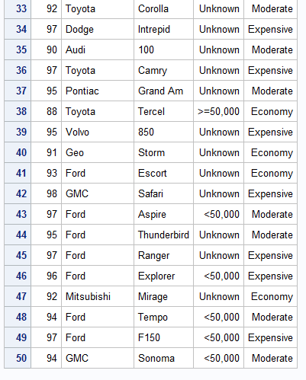

5

Code:

**data** college.cat2;

infile 'C:\Users\Samil\Desktop\Sem 1\Stats for programming\SAS 9.4\cats2.txt' firstobs=**2** missover;

input Cat $ **1**-**8** Side $**9**-**12** Week_0 Week_1 Week_2;

**run**;

**proc** **sort** data=college.cat2

out=work.cats_sort;

by Week_0;

**run**;

Title 'Cat';

**proc** **print** data=work.cats_sort;

var Cat Week_0;

**run**;

Title;

Log File:

45 data college.cat2;

46 infile 'C:\Users\Samil\Desktop\Sem 1\Stats for programming\SAS 9.4\cats2.txt' firstobs=2;

47 input Cat $ 1-8 Side $9-12 Week_0 Week_1 Week_2;

48 run;

NOTE: The infile 'C:\Users\Samil\Desktop\Sem 1\Stats for programming\SAS 9.4\cats2.txt' is:

Filename=C:\Users\Samil\Desktop\Sem 1\Stats for programming\SAS 9.4\cats2.txt,

RECFM=V,LRECL=32767,File Size (bytes)=380,

Last Modified=20 September 2017 20:30:31,

Create Time=20 September 2017 20:30:31

NOTE: 8 records were read from the infile 'C:\Users\Samil\Desktop\Sem 1\Stats for programming\SAS

9.4\cats2.txt'.

The minimum record length was 40.

The maximum record length was 40.

NOTE: The data set COLLEGE.CAT2 has 8 observations and 5 variables.

NOTE: DATA statement used (Total process time):

real time 0.06 seconds

cpu time 0.06 seconds

49

50 /*Sort by Week 0*/

51 proc sort data=college.cat2

52 out=work.cats_sort;

53 by Week_0;

54 run;

NOTE: There were 8 observations read from the data set COLLEGE.CAT2.

NOTE: The data set WORK.CATS_SORT has 8 observations and 5 variables.

NOTE: PROCEDURE SORT used (Total process time):

real time 0.05 seconds

cpu time 0.06 seconds

55

56 Title 'Cat';

57

58 proc print data=work.cats_sort;

59 var Cat Week_0;

60 run;

NOTE: There were 8 observations read from the data set WORK.CATS_SORT.

NOTE: PROCEDURE PRINT used (Total process time):

real time 0.19 seconds

cpu time 0.04 seconds

61

62 Title;

Output:

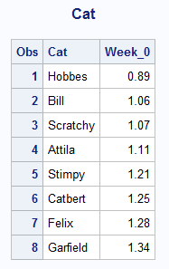

6

Code:

**data** college.hanks;

infile "C:\Users\Samil\Desktop\Sem 1\Stats for programming\SAS 9.4\hanks.txt" firstobs=**2** expandtabs missover;

input Title $25. Year Length MPAA $ Action Drama Humor Sex Violence Suspense Offbeat;

format MPAA $mpaa.;

**run**;

/*Data is sorted by year in ascending order */

**proc** **sort** data=college.HANKS

out=work.HANKS_sort;

by Year;

**run**;

Title 'Hanks';

**proc** **print** data=work.HANKS_sort;

*Only 3 cloumns have to printed;

var Title Year MPAA;

**run**;

Title;

Log file:

157 data college.hanks;

158 infile "C:\Users\Samil\Desktop\Sem 1\Stats for programming\SAS 9.4\hanks.txt" firstobs=2

158! expandtabs missover;

159 input Title $25. Year Length MPAA $ Action Drama Humor Sex Violence Suspense Offbeat;

160 format MPAA $mpaa.;

161 run;

NOTE: The infile "C:\Users\Samil\Desktop\Sem 1\Stats for programming\SAS 9.4\hanks.txt" is:

Filename=C:\Users\Samil\Desktop\Sem 1\Stats for programming\SAS 9.4\hanks.txt,

RECFM=V,LRECL=32767,File Size (bytes)=2283,

Last Modified=14 September 2017 11:00:35,

Create Time=14 September 2017 11:00:34

NOTE: 22 records were read from the infile "C:\Users\Samil\Desktop\Sem 1\Stats for

programming\SAS 9.4\hanks.txt".

The minimum record length was 98.

The maximum record length was 98.

NOTE: The data set COLLEGE.HANKS has 22 observations and 11 variables.

NOTE: DATA statement used (Total process time):

real time 0.02 seconds

cpu time 0.00 seconds

162

163 /*Data is sorted by year in ascending order */

164 proc sort data=college.HANKS

165 out=work.HANKS_sort;

166 by Year;

167 run;

NOTE: There were 22 observations read from the data set COLLEGE.HANKS.

NOTE: The data set WORK.HANKS_SORT has 22 observations and 11 variables.

NOTE: PROCEDURE SORT used (Total process time):

real time 0.03 seconds

cpu time 0.00 seconds

168 Title 'Hanks';

169

170 proc print data=work.HANKS_sort;

171 *Only 3 cloumns have to printed;

172 var Title Year MPAA;

173 run;

NOTE: There were 22 observations read from the data set WORK.HANKS_SORT.

NOTE: PROCEDURE PRINT used (Total process time):

real time 0.19 seconds

cpu time 0.01 seconds

174

175 Title;

Output:

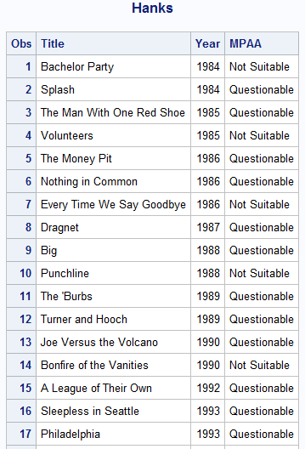

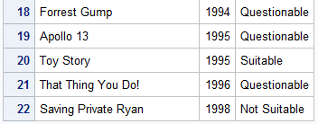

7

Code:

**data** college.iris;

/*Only first 50 observation has to be printed*/

infile "C:\Users\Samil\Desktop\Sem 1\Stats for programming\SAS 9.4\iris.txt" firstobs=**2**;

input CLASS :$10. SL : **4.0** SW : **4.0** PL : **4.0** PW : **4.0**;

*Column names have been changed;

label CLASS ='Class of Plant'

SL ='Saple Lenght'

SW ='Saple Width'

PL ='P Lenght'

PW ='P Width';

**run**;

Title "IRIS";

/*Data is sorted by SW in descending order*/

**proc** **sort** data=college.iris

out=work.iris_sort;

by descending SW;

**run**;

**proc** **print** data=work.iris_sort (obs=**50**) label;

**run**;

Title;

Log File:

115 data college.iris;

116 /*Only first 50 observation has to be printed*/

117 infile "C:\Users\Samil\Desktop\Sem 1\Stats for programming\SAS 9.4\iris.txt" firstobs=2;

118 input CLASS :$10. SL : 4.0 SW : 4.0 PL : 4.0 PW : 4.0;

119 *Column names have been changed;

120 label CLASS ='Class of Plant'

121 SL ='Saple Lenght'

122 SW ='Saple Width'

123 PL ='P Lenght'

124 PW ='P Width';

125 run;

NOTE: The infile "C:\Users\Samil\Desktop\Sem 1\Stats for programming\SAS 9.4\iris.txt" is:

Filename=C:\Users\Samil\Desktop\Sem 1\Stats for programming\SAS 9.4\iris.txt,

RECFM=V,LRECL=32767,File Size (bytes)=6643,

Last Modified=20 September 2017 22:50:43,

Create Time=20 September 2017 22:51:01

NOTE: 150 records were read from the infile "C:\Users\Samil\Desktop\Sem 1\Stats for

programming\SAS 9.4\iris.txt".

The minimum record length was 42.

The maximum record length was 42.

NOTE: The data set COLLEGE.IRIS has 150 observations and 5 variables.

NOTE: DATA statement used (Total process time):

real time 0.07 seconds

cpu time 0.04 seconds

126

127 Title "IRIS";

128

129 /*Data is sorted by SW in descending order*/

130 proc sort data=college.iris

131 out=work.iris_sort;

132 by descending SW;

133 run;

NOTE: There were 150 observations read from the data set COLLEGE.IRIS.

NOTE: The data set WORK.IRIS_SORT has 150 observations and 5 variables.

NOTE: PROCEDURE SORT used (Total process time):

real time 0.05 seconds

cpu time 0.06 seconds

134

135 proc print data=work.iris_sort (obs=50) label;

136 run;

NOTE: There were 50 observations read from the data set WORK.IRIS_SORT.

NOTE: PROCEDURE PRINT used (Total process time):

real time 0.17 seconds

cpu time 0.06 seconds

137

138 Title;

Output:

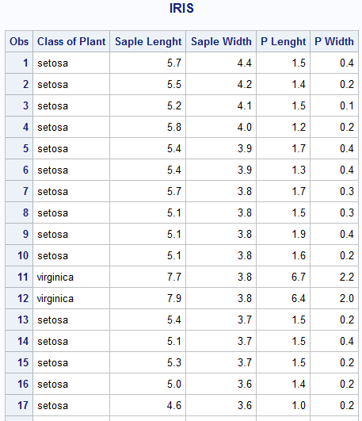

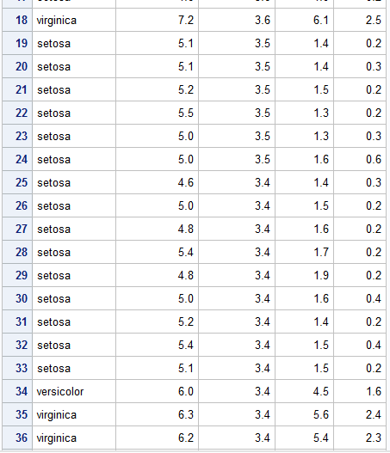

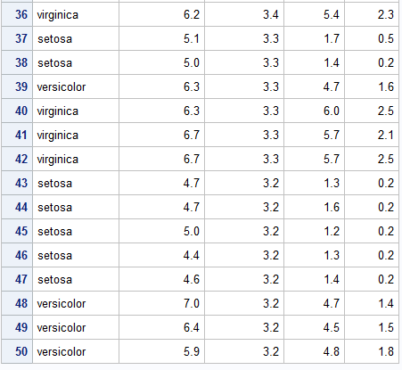

8

Part1

Code:

**data** college.ryan;

infile 'C:\Users\Samil\Desktop\Sem 1\Stats for programming\SAS 9.4\ryan.txt' firstobs=**2** missover expandtabs;

input @**1** title $25. roger nytimes usat ;

**proc** **print** data=college.ryan;

Title "Ryan";

**run**;

Title;

Log File:

240 data college.ryan;

241 infile 'C:\Users\Samil\Desktop\Sem 1\Stats for programming\SAS 9.4\ryan.txt' firstobs=2

241! missover expandtabs;

242 input @1 title $25. roger nytimes usat ;

243

NOTE: The infile 'C:\Users\Samil\Desktop\Sem 1\Stats for programming\SAS 9.4\ryan.txt' is:

Filename=C:\Users\Samil\Desktop\Sem 1\Stats for programming\SAS 9.4\ryan.txt,

RECFM=V,LRECL=32767,File Size (bytes)=541,

Last Modified=05 September 2017 10:16:46,

Create Time=05 September 2017 10:16:46

NOTE: 21 records were read from the infile 'C:\Users\Samil\Desktop\Sem 1\Stats for

programming\SAS 9.4\ryan.txt'.

The minimum record length was 13.

The maximum record length was 32.

NOTE: The data set COLLEGE.RYAN has 21 observations and 4 variables.

NOTE: DATA statement used (Total process time):

real time 0.01 seconds

cpu time 0.01 seconds

244 proc print data=college.ryan;

245 Title "Ryan";

246 run;

NOTE: There were 21 observations read from the data set COLLEGE.RYAN.

NOTE: PROCEDURE PRINT used (Total process time):

real time 0.17 seconds

cpu time 0.01 seconds

247

248 Title;

Output:

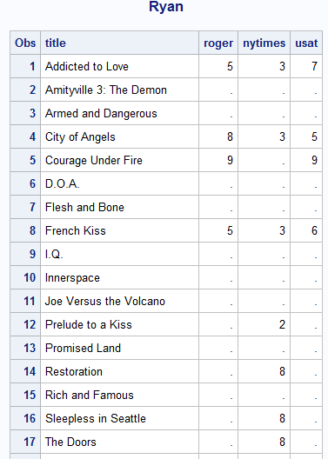

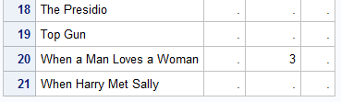

Part 2

Code:

options pageno=**385** missing='?' skip=**20** firstobs=**5** obs=**12**;

**run**;

**data** college.ryan;

infile 'C:\Users\Samil\Desktop\Sem 1\Stats for programming\SAS 9.4\ryan.txt' firstobs=**2** missover expandtabs;

input @**1** title $25. roger nytimes usat ;

**proc** **print** data=college.ryan;

Title "Ryan";

**run**;

Title;

options pageno=**1** missing='.' skip=**0** firstobs=**1** obs=MAX;

**run**;

Log file:

249 options pageno=385 missing='?' skip=20 firstobs=5 obs=12;

250 run;

251

252 data college.ryan;

253 infile 'C:\Users\Samil\Desktop\Sem 1\Stats for programming\SAS 9.4\ryan.txt' firstobs=2

253! missover expandtabs;

254 input @1 title $25. roger nytimes usat ;

NOTE: The infile 'C:\Users\Samil\Desktop\Sem 1\Stats for programming\SAS 9.4\ryan.txt' is:

Filename=C:\Users\Samil\Desktop\Sem 1\Stats for programming\SAS 9.4\ryan.txt,

RECFM=V,LRECL=32767,File Size (bytes)=541,

Last Modified=05 September 2017 10:16:46,

Create Time=05 September 2017 10:16:46

NOTE: 11 records were read from the infile 'C:\Users\Samil\Desktop\Sem 1\Stats for

programming\SAS 9.4\ryan.txt'.

The minimum record length was 13.

The maximum record length was 30.

NOTE: The data set COLLEGE.RYAN has 11 observations and 4 variables.

NOTE: DATA statement used (Total process time):

real time 0.10 seconds

cpu time 0.01 seconds

255 proc print data=college.ryan;

256 Title "Ryan";

257 run;

NOTE: There were 7 observations read from the data set COLLEGE.RYAN.

NOTE: PROCEDURE PRINT used (Total process time):

real time 0.20 seconds

cpu time 0.01 seconds

258 Title;

Output:

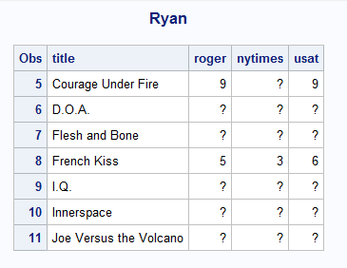

Explanation:

1 Pageno specifies a beginning page number from where SAS will produce the output. pageno=385 will print the output on the 385th pageno. After using pageno function it is necessary to assign it to 0 else the same output will come even if another program is ran.

2 missing='?' replaces all blank spaces with a '?'.

3 firstobs=5 will read from the 5th line from the top and will skip the

first four line.

4 skip function is used for skipping that many number of rows on the page.

However I can see no significant changes in the output.

5 obs=12 will read only till the line number specified. It will read the

first 12 lines of the page

9

Code:

/*Formats*/

**proc** **format**;

value $rainbow 'R','G','B'='Group 1'

'Y','O' = 'Group 2'

' '= 'Not Given'

Other ='Group 3';

**run**;

**data** colors;

input Color : $1. @@;

format Color $rainbow. ;

datalines;

R R B G Y Y . . B G R B G Y P O O V V B

;

**run**;

title 'Colors' ;

**proc** **print** data=colors;

**run**;

/*Procedure for Frequency*/

**PROC** **FREQ** DATA=colors;

TABLES Color;

**RUN**;

Log File:

442 data colors;

443 input Color : $1. @@;

444 format Color $rainbow. ;

445 datalines;

NOTE: SAS went to a new line when INPUT statement reached past the end of a line.

NOTE: The data set WORK.COLORS has 20 observations and 1 variables.

NOTE: DATA statement used (Total process time):

real time 0.01 seconds

cpu time 0.00 seconds

447 ;

448 run;

449

450 title 'Colors' ;

451

452 proc print data=colors;

453

454 run;

NOTE: There were 20 observations read from the data set WORK.COLORS.

NOTE: PROCEDURE PRINT used (Total process time):

real time 0.17 seconds

cpu time 0.04 seconds

455 /*Procedure for Frequency*/

456 PROC FREQ DATA=colors;

457 TABLES Color;

458 RUN;

NOTE: There were 20 observations read from the data set WORK.COLORS.

NOTE: PROCEDURE FREQ used (Total process time):

real time 0.22 seconds

cpu time 0.03 seconds

Output:

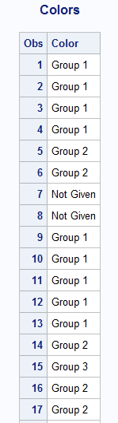

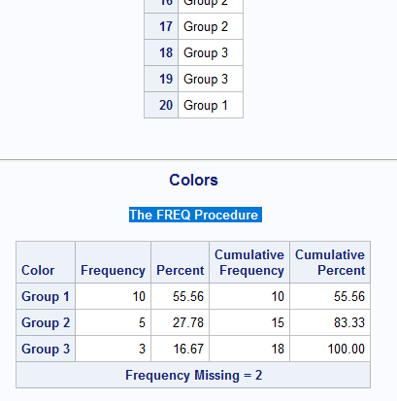

10

Code:

libname myfmts 'C:\Users\Samil\Desktop\Sem 1\Stats for programming\SAS 9.4';

**proc** **format** library=myfmts;

value YESNO **1**='Yes'

**2**='No';

value $YESNO 'Y'= 'Yes'

'N'= 'No';

value $Gender 'M' = 'Male'

'F' = 'Female';

value Age20yrs low-**20** = **1**

**21**-**40** = **2**

**41**-**60** = **3**

**61**-**80** = **4**

**81**-high = **5**;

**run**;

**proc** **format** library=myfmts fmtlib;

Title "Formats";

**run**;

Title;

Log File:

459 libname myfmts 'C:\Users\Samil\Desktop\Sem 1\Stats for programming\SAS 9.4';

NOTE: Libref MYFMTS refers to the same physical library as COLLEGE.

NOTE: Libref MYFMTS was successfully assigned as follows:

Engine: V9

Physical Name: C:\Users\Samil\Desktop\Sem 1\Stats for programming\SAS 9.4

460

461 proc format library=myfmts;

462 value YESNO 1='Yes'

463 2='No';

NOTE: Format YESNO is already on the library MYFMTS.FORMATS.

NOTE: Format YESNO has been written to MYFMTS.FORMATS.

464 value $YESNO 'Y'= 'Yes'

465 'N'= 'No';

NOTE: Format $YESNO is already on the library MYFMTS.FORMATS.

NOTE: Format $YESNO has been written to MYFMTS.FORMATS.

466 value $Gender 'M' = 'Male'

467 'F' = 'Female';

NOTE: Format $GENDER is already on the library MYFMTS.FORMATS.

NOTE: Format $GENDER has been written to MYFMTS.FORMATS.

468 value Age20yrs low-20 = 1

469 21-40 = 2

470 41-60 = 3

471 61-80 = 4

472 81-high = 5;

NOTE: Format AGE20YRS is already on the library MYFMTS.FORMATS.

NOTE: Format AGE20YRS has been written to MYFMTS.FORMATS.

473 run;

NOTE: PROCEDURE FORMAT used (Total process time):

real time 0.01 seconds

cpu time 0.00 seconds

474

475

476 proc format library=myfmts fmtlib;

477 Title "Formats";

478 run;

NOTE: PROCEDURE FORMAT used (Total process time):

real time 0.11 seconds

cpu time 0.01 seconds

479

480 Title;

Output:

